California State University, Fresno
Department of Communication
Internship Program
© 2010 Department of Communication, California State University, Fresno

Internship Program Director
Scott D. Moore, Ph.D.
Professor
California State University, Fresno
Department of Communication
5201 North Maple Ave, Mail Stop SA 46
Fresno, CA 93740-8027
Personal Phone: 559.278.3010
Department Phone: 559.278.2826
FAX: 559.278.4113

California State University, Fresno
Department of Communication
Internship Program
Comm 179

Table of Contents:
- General Overview
- Guidelines for Students & Participating Agencies
- Guidelines for Students Completing an Intern Project
- Internship Contract
- Eight Week Progress Report
- Final Progress Report

Internship in Communication

General Overview
Internships are offered to majors (advanced juniors or graduate students) in Communication with a minimum grade average of 2.87 (B-), in good standing with the university. Internships are intended for individuals to pursue professional careers in government, business, industry, social agencies, and other related fields. The interns, having finished most of the classroom work, can benefit from a learning experience in a setting outside of the classroom where directed observation and work experience provide opportunities to apply theoretical knowledge to real life situations.
The curriculum of our Communication majors includes courses in: interpersonal communication, small group communication, communication analysis, conflict management, managerial skills, organizational communication, leadership, consulting, business and professional presentations, and other courses which develop knowledge and skills the communicating with other human beings. Although the skills obtained in our public speaking courses are not overlooked, oral delivery is not the focus of our communication program. The communication student, upon completing his/her program, is equipped for a broad area of professional responsibilities which include: management, sales, public relations, personnel, industrial relations, training and development, consulting and politics and government. Our interns have been successfully placed in banks, churches, political headquarters, social service agencies, nonprofit agencies, national and regional companies, and civic agencies to name a few.

Catalogue Description
COMM 179. Internship (1-6; max total 12)
Prerequisites: major in communication, at least 75 units completed and permission of instructor. Supervised work experience in government, business, social agencies, or nonprofit organizations. CR/NC grading only.

Guidelines for Students & Participating Agencies

Establishing an Internship
Any organization or agency desiring to place an intern should contact the Communication internship coordinator by phone or letter, indicating the basic nature of the internship available, and the organizational person who serves as the intern supervisor. The internship should provide a capstone educational experience and all duties should directly relate to specific communication objectives. Upon receipt of this request and, depending on availability of student interns, a student will be sent to the organization for an interview. If the nature of the internship is acceptable to the organization and the student, then a contract will be drawn up involving the student, the agency supervisor and the Communication internship coordinator. The agency supervisor will provide periodic progress reports to the internship coordinator who will work directly with him or her in evaluating the interns’ performance. The internship director may, from time to time, initiate site visits during the course of the semester. Internships outside of the Fresno area, while not ideal, are possible. The students’ grade (credit/no credit) will be based on this joint evaluation process.

Time Requirements
Internships are normally for a 12-15 week period coinciding with the semester in session. Interns are expected to spend from 8-12 hours per week (per 3 units of credit) at their internship duties. Intern agency supervisory responsibilities should consist of observation and duties which would assist the intern in integrating his/her knowledge with the practical operations of the organization. Normally, interns will not be paid; consequently they should not be performing perfunctory duties which a paid employee would usually perform. The specific responsibilities would be determined through joint agreement among the organizational supervisor, the intern, and the faculty internship coordinator.

Department of Labor and the Fair Labor Standards Act
Students enrolled in Comm 179 may perform internship duties for either a non-profit or a for-profit organization. Non-profit organizations which employ an internship are viewed as providing an opportunity for training as volunteer work. Internships which are attached to a for-profit organization may be either paid or unpaid. Paid internships are generally associated with the prevailing minimum wage attached to a specific time period. Provisions associated with the Fair Labor Standards Act provide a special category for unpaid internships that meet the following criteria:
1) The internship, even though it includes actual operation of the facilities of the employer, is similar to training which would be given in an educational environment;
2) The internship experience is for the benefit of the intern;
3) The intern does not displace regular employees, but works under close supervision of existing staff;
4) The employer that provides the training derives no immediate advantage from the activities of the intern; and on occasion its operations may actually be impeded;
5) The intern is not necessarily entitled to a job at the conclusion of the internship; and
6) The employer and the intern understand the intern is not entitled to wages for the time spent in the internship.
For more detailed information on the Fair Labor Standards Act, please see the following information (Fact Sheet #71: Internship Programs Under the Fair Labor Standards Act).
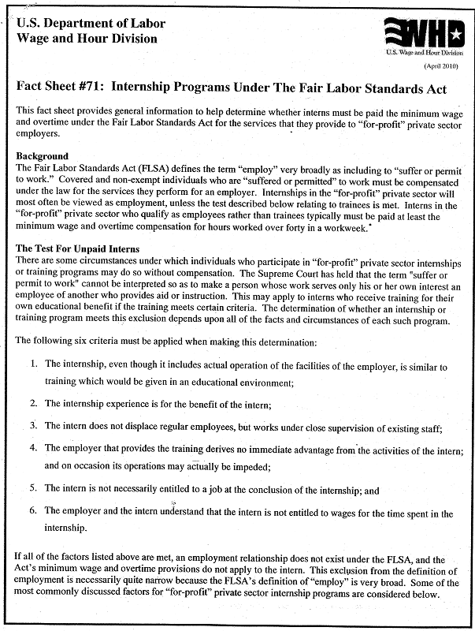

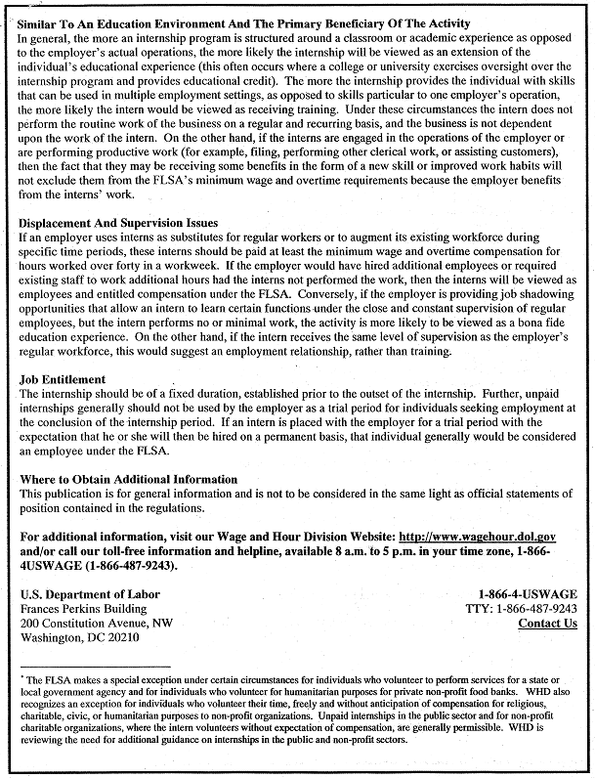

Guidelines for Students Completing an Internship Project

In order to receive academic credit for work under the communication internship course, the following information must be submitted to and approved by the internship coordinator.
- Internship Contract: This document must be on file with the internship coordinator before the intern is officially enrolled in the course. The contract, which is appended to this document, includes the following:.
  - Names, addresses, and phone numbers of intern, intern agency and intern agency supervisor.
  - Clear statement of goals for the internship to be provided by the student with the advice of the agency supervisor. These goals should meet communication behavioral objectives for an internship
  - A clear description of the intern’s duties which are designed to meet the goals of the internship.
- Progress Report: Before the end of the eighth week of instruction the intern supervisor should submit the following:
  - A formal statement by the intern indicating his/her progress in the internship. The report should include any changes in objectives and duties as well as the intern’s perceptions of how well the objectives are being fulfilled.
  - Completion of the eight week progress report from in which the intern supervisor indicates their perceptions of how well the intern is performing and the extent to which the initial goals of the internship are being met.
- Final Reports: On or before the last regularly scheduled day of instruction for the semester, the following should be submitted:
  - Final Intern Report: The intern should submit a final report which includes:
      - The intern’s perceptions of how well the objectives were met,
      - Any specific accomplishments the intern thinks occurred during the internship,
      - A recommendation, with supporting statements, concerning the appropriateness of the intern organization for future potential internship placements.
  - Final Supervisor’s Report: The intern supervisors should submit the “final progress report” form which includes:
      - The supervisor’s perceptions of how well the intern accomplished the responsibilities of the internship,
      - A brief summary of the intern’s strengths and weaknesses as observed during the internship period,
      - A recommendation concerning the grade which the intern should receive, wither credit or no credit,
      - Final internship reports shall be on file in the department office.

California State University, Department of Communication
Communication Internship Contract
Student | Name:
 | Phone:
 | ID:
 | Fresno State Email:
Supervisor | Name:
 | Organization
 | Title
 | Phone
 | Email
Type of Organization |  | Nonprofit Organization (paid or unpaid), |  | For Profit Organization Paid Internship | For Profit Organization Unpaid Internship

Describe the Purpose & Goals of the Internship:

List the Knowledge and Skills to be Acquired

Agreed Schedule (Both Dates & Times):

Approvals: The undersigned agree to the educational merit of this internship. Interns serving at “For-Profit, Unpaid Internships” signatures indicate understanding and compliance or exemption from the Fair Labor Standards Act (see pages 5-8 for more information).

________________________ | ________________________ | ________________________
Prospective Student Intern | Prospective Intern Supervisor | Dept. of Communication  Internship Coordinator

California State University, Department of Communication
Mid-Semester Progress Report (to be completed by the Supervisor)
Student | Name:
Supervisor | Name:
 | Organization
 | Title
 | Phone
 | Email

Describe the Quality of the Student’s Performance:

Describe The Intern’s Progress Toward Contract Goals:

Describe Any Problems Having to do With Absenteeism, Tardiness, etc:

If You Had to Assign A Grade At This Point Would It Be:
Credit No Credit

Do you wish to be contacted by the Department of Communication Internship Coordinator to discuss this intern’s performance in confidence?
Yes, please contact me. No, contact is not necessary at this point.

 | ________________________ | ________________________
 | Intern Supervisor | Date
This form may be hand-carried by the student intern, emailed to scottm@csufresno.edu, or faxed to 559.278.4113, attn: Dr. Scott Moore.

California State University, Department of Communication
Final Progress Report
(to be completed by the Supervisor)
Student | Name:
Supervisor | Name:
 | Organization
 | Title
 | Phone
 | Email

Describe the Quality of the Student’s Performance:

Describe The Intern’s Progress Toward Contract Goals:

Describe Any Problems Having to do With Absenteeism, Tardiness, etc:

I recommend the following grade should be assigned to the student for their performance:
Credit No Credit

Do you wish to be contacted by the Department of Communication Internship Coordinator to discuss this intern’s performance in confidence?
Yes No.

Would you consider hosting a Department of Communication student intern in the future?
Yes No.

 | ________________________ | ________________________
 | Intern Supervisor | Date
This form may be hand-carried by the student intern, emailed to scottm@csufresno.edu, or faxed to 559.278.4113, attn: Dr. Scott Moore.

For More Information, Please Contact:

Department of Communication
Internship Program Director
Scott D. Moore, Ph.D.
Professor
California State University, Fresno
Department of Communication
5201 North Maple Ave, Mail Stop SA 46
Fresno, CA 93740-8027
Personal Phone: 559.278.3010
Department Phone: 559.278.2826
FAX: 559.278.4113

